EASTER DAY OF THE LORD’S RESURRECTION 20th April
A day of hope: of flowers and candles, new colour and new light. A day of smiles and of friendship, new joy and new companionship in Christ. A day of hope for those who suffer and who are sad. A day which promises the victory of God’s love over sin and death.
MASSES
Vigil Saturdays: 6pm
Sundays: 9am & 11am
Weekdays: Monday to Saturday 10am
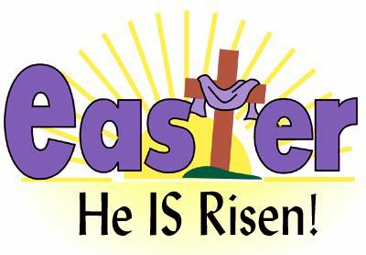
CONFESSIONS
Saturdays 10.30am and 5.30pm

Family of Parishes: Ballinlough, Blackrock,
Blackrock Road, and Mahon

Monsignor Gearóid Dullea Co-P.P.
Tel: 021- 429 2296
Emergency Mobile 087 – 239 5434

Parish Office: 021 - 429 4332
Email: parishoffice@ballinloughparishcork.ie
Web: www.ballinloughparishcork.ie
Webcam: www.churchservices.tv/ballinloughlourdes

Deaths
We remember in our prayers Helen Dunlea, Beechwood Park, may she rest in peace. Our sincere sympathies to her family, friends, and neighbours.
Eternal rest grant unto her O Lord and may the light of God surround her forever. May her soul and the souls of all the faithful departed, through the mercy of God, rest in peace. Amen

Easter Collection today is for the support of the Clergy.

EDEL QUINN PRAYER GROUP
Will resume on Thursday 1st May at 8p.m. in the Pastoral Centre.
All welcome.

SMA Pilgrimage to Knock Saturday 24th May
Bus departing from SMA Church, Blackrock Road at 8.30a.m. sharp.
Estimated time of return 10p.m. Please book at reception €30 cash only, non-refundable.
Tea/coffee and scones (morning), evening meal €31 per person payable on the day.

Ballinlough Parish Over 55’s Mixed Golf Scramble 2025
We are delighted to announce that the above outing will be held on
Thursday 22nd May 2025.

Venue: Douglas Golf Club
Time: 10.30a.m. to 12.20p.m.
Mixed Scramble open Draw.
Entry fee €50 (CASH) per person, includes
2 course lunch + tea/coffee and
and great local company.

Envelope should be marked
PARISH OUTING.

Please include details of Name, Club, Handicap, and contact number which
should be handed in (put in letterbox) with entry fee not later than
May 1st to: Parochial House, Our Lady of Lourdes Church, Ballinlough Road.

PLEASE PAY WHEN SUBMITTING ENTRY.

Jubilee of Hope – Holy Year
The parish of Ballinlough are making a pilgrimage to Lourdes for the
Holy Year. From Friday 19th September to Wednesday 24th September.
Return flights from Cork to Lourdes.
Cost: €995 per person sharing staying in the Saint Sauveur Hotel.
For general enquiries about the pilgrimage contact 085 – 2525 040

Cork Alzheimer’s Café – Next meeting Friday 25th April.
A safe place for people with Alzheimer’s and other dementias, their carers, family, and friends, along with social and health professionals to meet.
Last Friday of each month 11-12.30p.m. in St. Finbarr’s Hospital,
Douglas Road.
Light refreshments provided free of charge.
Chair Yoga led by Martina Egar. All welcome.



